ASIST Application Logo

HITL Training System

SME Guide

# Overview

The HITL (Human-in-the-Loop) Training System allows Subject Matter Experts to correct AI responses and train the system to apply those corrections to similar questions in the future.

# Test Case Documentation

## Original Question (Training Source)

**Question:** *"I am developing a case for MIDS JTRS terminals and the approval process is taking longer than expected, delaying my case submission. What should I do?"*

### Original AI Response

* Intent: distinction (incorrect)
* Entities: None extracted
* Answer: Authority-style response about DSCA approval hierarchy

### SME Corrections Applied

1. Intent changed from "distinction" to "process"
2. Entity added: "MIDS JTRS" (type: Tools/Technologies/Systems)
3. Answer replaced with step-by-step process guide including:

- Step 1: Contact Your Case Manager

- Step 2: Request LOA Prioritization (SAMM C5.4.22)

- Step 3: Check for Missing Documents

- Step 4: Consider Pre-Case Review (SAMM C5.4.16)

- Key Contacts and Timeline information

- Citations: SAMM C5.4.22, C5.4.16, C6.1.3

## Similar Question (Test Result)

**Question:** *"My MIDS JTRS case is stuck in approval and getting delayed. What steps should I take?"*

### System Behavior

* Pattern matching detected 47% similarity based on common keywords
* Common keywords found: mids, jtrs, case, approval
* System automatically applied trained corrections

### Response Returned

* Intent: process (from training)
* Entities: MIDS JTRS (from training)
* Answer: Same corrected step-by-step guide (from training)

# SME Workflow

The HITL Dashboard provides three agents for reviewing and correcting AI responses. Below are the screenshots showing each agent's interface and available options.

## Agent 1: Intent Classification Analysis

If the AI has classified the intent incorrectly, use the "Manual Override" option to correct it. This trains the system to recognize similar questions with the correct intent.

Intent Classification Analysis interface

Figure 1: Agent 1 - Intent Classification Analysis with Manual Override option

**HITL Decision Options:**

* **Accept Intent Classification** - Accept the AI's intent if correct
* **Re-run Agent 1** - Re-analyze the question
* **Manual Override** - Enter the correct intent manually (trains the system)

### Example: Accept Intent Classification

When the AI correctly classifies the intent, click "Accept Intent Classification" to approve it. This marks the agent's output as verified.

Confirmation dialog for accepting intent

Figure 1a: Confirmation dialog when clicking Accept Intent Classification

Success message after accepting intent

Figure 1b: Success message showing intent approved

### Backend Verification

The backend terminal shows confirmation that the intent was approved:

Backend log showing intent approved

Figure 1c: Backend confirmation - Intent APPROVED with question hash

### Example: Re-run Agent 1

When you want the AI to re-analyze the intent, click "Re-run Agent 1". This actually calls the AI model to perform a fresh intent classification.

Confirmation dialog for re-running intent

Figure 1d: Confirmation dialog when clicking Re-run Agent 1

Loading indicator while AI processes

Figure 1e: Loading indicator while AI re-analyzes the intent

Success message with new intent

Figure 1f: Success message showing new intent classification with confidence score

### Backend Verification - Re-run

The backend terminal shows the AI actually processing the request:

Backend log showing intent re-run

Figure 1g: Backend shows AI processing with Ollama model and new intent result

## Agent 2: Entity Extraction Analysis

If entities are missing or incorrect, use "Add Missing Entity" or "Remove Incorrect Entity" options. Each correction trains the system to recognize entities in similar questions.

Entity Extraction Analysis interface

Figure 2: Agent 2 - Entity Extraction Analysis with Add/Remove Entity options

**HITL Decision Options:**

* **Accept Entity Extraction** - Accept if all entities are correct
* **Add Missing Entity** - Add entity that AI missed (trains the system)
* **Remove Incorrect Entity** - Remove wrongly extracted entity (trains the system)
* **Re-run Agent 2** - Re-analyze entities

### Example: Remove Incorrect Entity

When an extracted entity is too generic or incorrect, use "Remove Incorrect Entity" to remove it. This trains the system to avoid extracting similar incorrect entities in the future.

Modal dialog for removing entity

Figure 2a: Remove Entity modal with dropdown to select entity

Dropdown showing available entities

Figure 2b: Dropdown showing all extracted entities to choose from

Entity selected for removal

Figure 2c: Generic entity "programs" selected for removal

Success message after removal

Figure 2d: Success message confirming entity removed and system trained

### Backend Verification - Remove Entity

The backend terminal confirms the entity was removed and the system was trained:

Backend log showing entity removal

Figure 2e: Backend shows entity training saved and corrections updated

### Example: Accept Entity Extraction

After removing incorrect entities, you can accept the remaining valid entities. This marks the entity extraction as verified and approved.

Entity list after removal

Figure 2f: Only 2 valid entities remaining after removing "programs"

Confirmation dialog

Figure 2g: Confirmation dialog for accepting entity extraction

Success message

Figure 2h: Success message showing 2 entities approved

### Backend Verification - Accept Entity

The backend confirms the entities were approved:

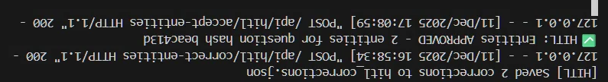

Figure 2i: Backend confirmation - Entities APPROVED with question hash

### Example: Re-run Agent 2

When you want the AI to re-extract entities, click "Re-run Agent 2". This calls the AI model to perform fresh entity extraction from the question.

Entity state before re-run

Figure 2j: Current entities before re-run (2 entities with 69% confidence)

Confirmation dialog

Figure 2k: Confirmation dialog for Re-run Agent 2

Success message with new entities

Figure 2l: Success message - Agent 2 re-run completed with 3 entities found

## Agent 3: Answer Generation Analysis

Agent 3 generates the final answer based on intent classification and extracted entities. SMEs can review, edit, or regenerate answers as needed.

**HITL Decision Options:**

* **Accept Answer** - Accept if the answer is satisfactory
* **Edit Answer** - Modify or replace the answer (trains the system)
* **Regenerate Answer** - Ask AI to generate a new answer
* **Escalate to SME** - Flag for senior SME review

### Example: Accept Answer

When the AI-generated answer is satisfactory, click "Accept Answer" to approve it. This marks the answer as verified.

Answer display before acceptance

Figure 3a: Generated answer with 954 chars and 80% confidence

Confirmation dialog

Figure 3b: Confirmation dialog for accepting answer

Success message

Figure 3c: Success message - Agent 3 (Answer) APPROVED

### Backend Verification - Accept Answer

The backend confirms the answer was approved:

Backend log

Figure 3d: Backend confirmation - Answer APPROVED with question hash

### Example: Edit Answer

If the generated answer needs improvement, use "Edit Answer" to provide a corrected response. This trains the system to return the corrected answer for similar questions.

Answer Generation Analysis interface

Figure 3e: Agent 3 - Edit Answer interface for modifying AI-generated responses

### Example: Regenerate Answer

When you want the AI to generate a completely new answer, click "Regenerate Answer". This calls the AI model to create a fresh response based on the question context.

Loading while AI generates answer

Figure 3f: Loading indicator while AI regenerates the answer

Success message with new answer

Figure 3g: Success message - Agent 3 re-run completed with 1446 chars generated

### Backend Verification - Regenerate Answer

The backend shows the AI processing and generating a new answer:

Backend log showing answer regeneration

Figure 3h: Backend shows Ollama AI processing and generating 1806 chars answer

# How Pattern Matching Works

## Keyword Extraction

The system extracts significant keywords from questions, filtering out common words like "what", "is", "the", "how", "should", etc.

## Matching Criteria

For a similar question to receive trained corrections:

* Minimum 2 common keywords required
* Minimum 40% bidirectional similarity score

## Bidirectional Scoring Formula

Score = (CommonKeywords/TrainedKeywords + CommonKeywords/QuestionKeywords) / 2

## Example Calculation

* Trained question keywords: developing, case, mids, jtrs, terminals, approval, process, submission (8 keywords)
* Similar question keywords: mids, jtrs, case, stuck, approval, delayed, steps, take, getting (9 keywords)
* Common keywords: mids, jtrs, case, approval (4 keywords)
* Score: (4/8 + 4/9) / 2 = (0.50 + 0.44) / 2 = 47%

*Since 47% exceeds the 40% threshold and there are more than 2 common keywords, the trained corrections are applied.*

# What Gets Applied

| **Exact Match (100%)** | **Pattern Match (40%+)** |
| --- | --- |
| Corrected Intent  Corrected Entities  Corrected Answer  **Confidence: 99%** | Corrected Intent  Corrected Entities  Corrected Answer  **Confidence: 90%** |

# Persistent Storage

All training data is saved to JSON files and persists across server restarts:

* intent_training.json
* entity_training.json
* answer_training.json
* hitl_corrections.json

# HITL Decision Required Buttons

At the bottom of each review, there are decision buttons for final review actions:

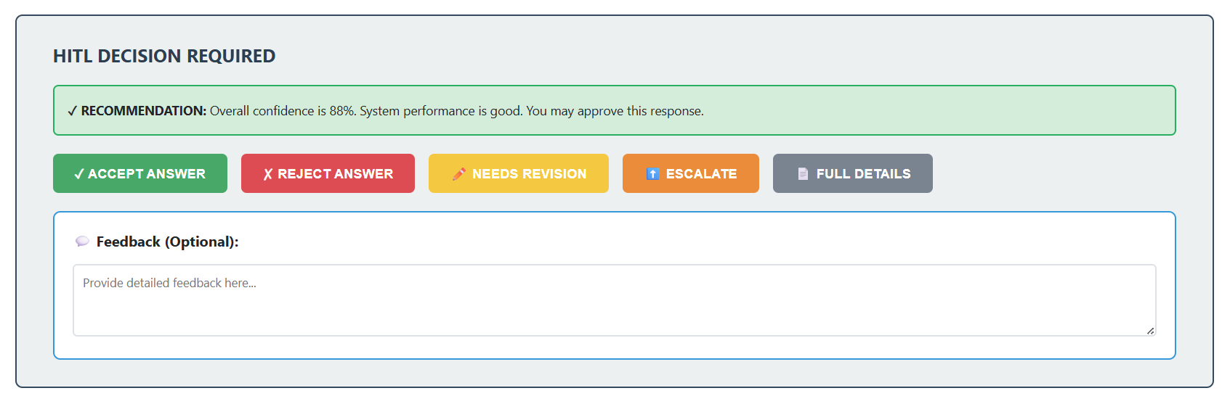

|  |  |
| --- | --- |
| **Button** | **Purpose & Action** |
| **✓ ACCEPT ANSWER** | Approve the review. Marks review as approved and moves to next review. |
| **✗ REJECT ANSWER** | Reject the review. Marks review as rejected. Feedback is optional but recommended. |
| **✏️ NEEDS REVISION** | Flag for revision. Marks review as needing improvement before approval. |
| **⬆️ ESCALATE** | Send to senior SME. Escalates the review to a senior reviewer for complex cases(Not implemented yet). |
| **📄 FULL DETAILS** | View complete info. Opens a modal with all review details including metadata. |

**Feedback (Optional):** SME can add notes in the feedback box to explain their decision. This feedback is stored with the review.

# Important Notes

* The system learns from every SME correction
* Similar questions (40% or more keyword overlap) will receive trained responses
* More specific corrections with unique keywords will have more targeted matching
* The system prioritizes exact matches over pattern matches

Document Generated: 12/12/2025